Beauty Parlour Appointment Booking
Project: GlamBook | Technology: HTML, CSS, JavaScript (localStorage)

Aim
To develop an appointment booking system for beauty parlours with slot availability checks and admin approval.

Algorithm
- Start: load parlours, services and appointments.
- User chooses parlour, service, date.
- Generate time slots; a slot is free if no appointment holds it (isFree).
- User picks a free slot; price is updated for the selected services.
- Appointment saved as Pending; admin confirms or rejects.
- Auto-cancel appointments that stay unconfirmed past the allowed time.
- Show booking result dialog to the user. Stop.

Result
The Beauty Parlour Appointment Booking was implemented successfully using HTML, CSS and JavaScript. All modules (login, role-based pages, data entry, search/booking and admin management) work correctly in the browser, and data persists using localStorage.

Implementation (Output Screenshots)
Home page
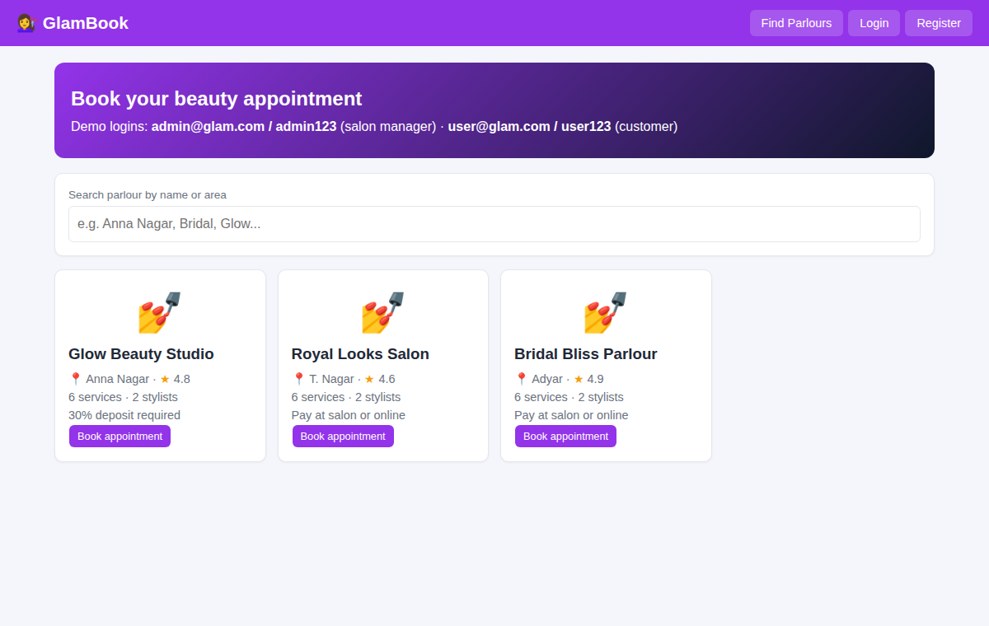
After login (admin / dashboard)
